How does the maternity nurse work?

The beginning of the pregnancy

If you are pregnant you can apply at Maternity care Tilly. Together we discuss the possibilities and your wishes. Then we choose a maternity nurse from our organization. It’s also possible to choose an independent maternity nurse by yourself.

After 32 weeks of pregnancy

The maternity nurse will take care of making an appointment with you for an intake interview. During an intake interview you can make appointments with the maternity nurse about the kind of care you will receive.

During labour

Are you going to give birth? When you are delivering your baby at home the maternity nurse comes directly to assist in childbirth. And when you delivered your baby in the hospital, she will come directly when you are back at home.

Contact with Maternity care Tilly?
Are your curious about maternity care Tilly after reading this information and do you want more information? Please feel free to contact us at. info@kraamzorgtilly.nl, or call:
015 - 251 00 11
015 - 785 05 22
06 - 51 96 45 66
06 - 10 01 31 68, after 21:00 o’clock

You can also take a look at our website www.kraamzorgtilly.nl or our Facebook page www.facebook.com/kraamzorgtilly

The best care for your newborn baby, as you desire.

Thanks for the heavenly maternity time! The pink cloud existed briefly.

-Manuela

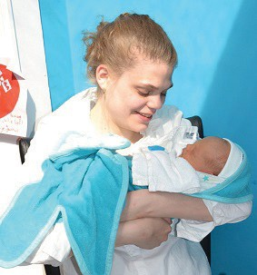
Great! Sweet, hardworking and knowledgeable!
-the Oosterhuis family

The nicest as possible maternity time for the whole family, that is what Maternity care Tilly stands for. During and after pregnancy, there is so much that you need to take care of. A maternity nurse is glad to help you out.

What is Maternity care Tilly?

Maternity care Tilly is a care organization that mediates between independent maternity nurses and families in a great part of South Holland. This means that the maternity nurses usually are not employed at the company. That means that you get a maternity nurse that fits your needs.

Expertise and well informed Professionalism is our priority: guaranteed good care of your baby. According to the law you will receive eight days of maternity care. Additional support is always possible of course.

The maternity nurses get regular training to keep abreast of the latest developments.

What does a maternity nurse?

A maternity nurse of Maternity care Tilly works along with the midwife as one team. She makes sure that you can rest after giving birth. The maternity nurse will take over various tasks from you, such as household chores and welcoming the visitors.

A maternity nurse will help you by giving (breast) feeding and washing the baby. So you will be optimal enjoying the first moments with your baby.

Help during labour
The maternity nurse also can assist the midwife or doctor when you deliver your baby at home.

Why choose a maternity nurse from Maternity care Tilly?

Five plus points in a row:
- The maternity care is available 24 hours a day.
- After the midwife calls her, the maternity nurse is available within one hour.
- The maternity care gives you clear information about breastfeeding and baby care.
- All maternity nurses are assessed on qualifications, experience and professional attitude.
- Maternity care Tilly has a number of English-speaking maternity nurses.

